Bociat Daniel-Tiberiu

1. Write an SQL statement to create a simple table **countries** including

columns country_id,country_name and region_id.

CREATE TABLE countries(

    country_id int NULL DEFAULT NULL,

    country_name varchar(40) NULL DEFAULT NULL,

    region_id decimal(10,0) NULL DEFAULT NULL

);

**2)**Write an SQL statement to insert a record with your own value into the table countries against each columns.

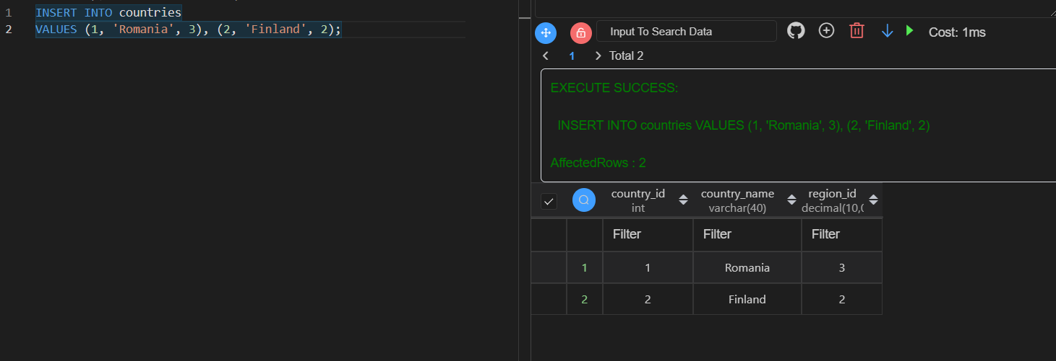

**3)** Write an SQL statement to insert records into the table countries to ensure that the country_id column will not contain any duplicate data and this will be automatically incremented and the column country_name will be filled up by 'N/A' if no value assigned for that column.

ALTER TABLE countries

MODIFY COLUMN country_id INT AUTO_INCREMENT PRIMARY KEY,

MODIFY COLUMN country_name VARCHAR(40) NOT NULL default 'N/A'

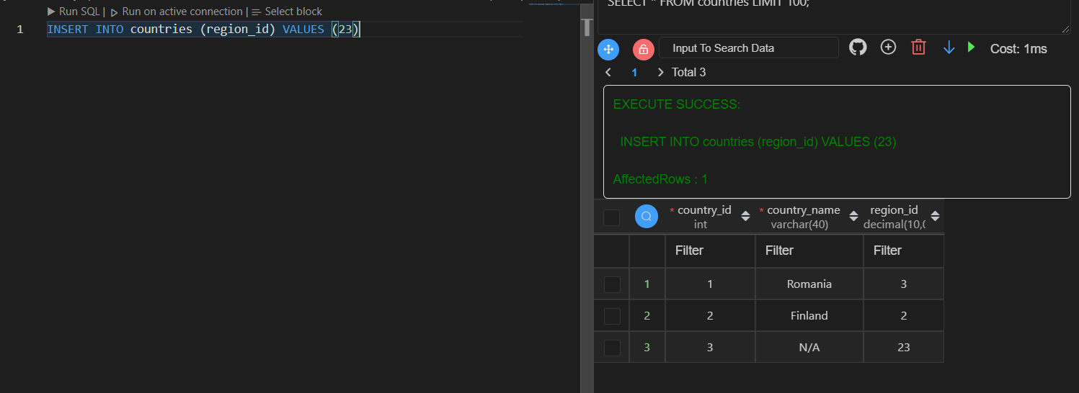

**4)** Write an SQL statement to change the email column of employees table with 'not available' for all employees.

UPDATE employees SET EMAIL = "not available"

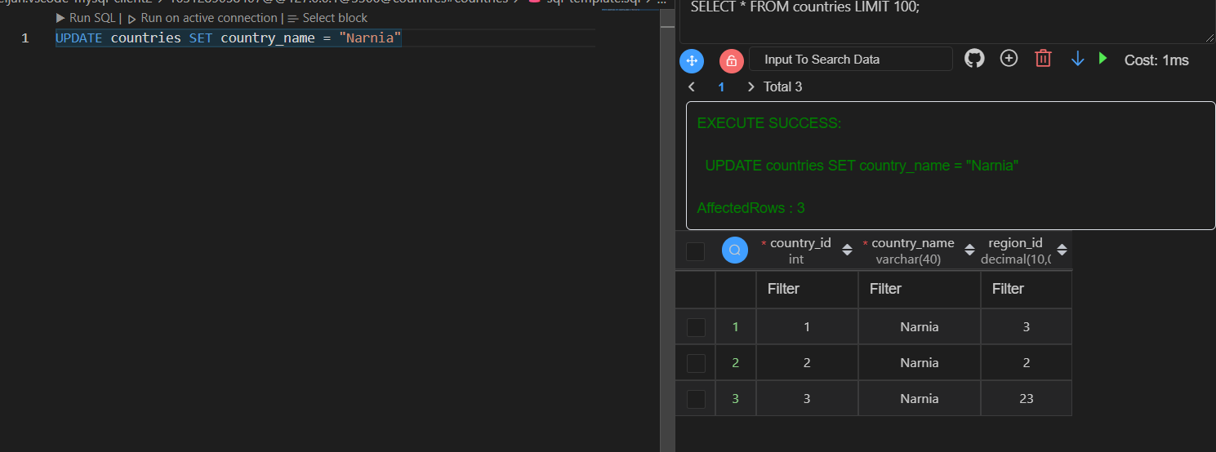 Tried it on the countries table to prove it works

**5)** Write an SQL statement to change the email column of employees table with 'not available' for those employees whose department_id is 80 and gets a commission is less than .20%

UPDATE employees SET EMAIL = "not available"

WHERE DEPARTMENT_ID = 80 AND COMMISSION_PCT < 0.2

Tried it on the countries table to prove it works

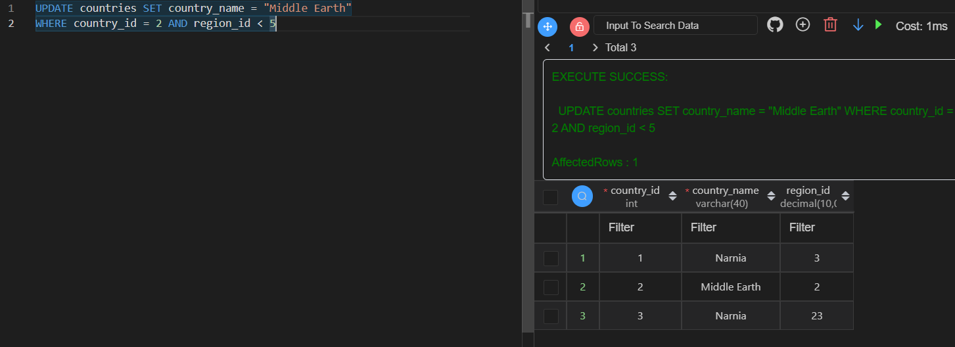

**6)** Write an SQL statement to add a column region_id to the table locations.

ALTER TABLE locations

ADD COLUMN region_id DECIMAL(10, 0) NULL DEFAULT NULL

**7)** Write an SQL statement to drop the column city from the table locations.

ALTER TABLE locations

DROP COLUMN city

**8)** Write an SQL statement to add a primary key for the column location_id in the locations table.

ALTER TABLE locations

ADD PRIMARY KEY(location_id)

For these exercises Visual Studio Code was used to run Queries and view the Tables.